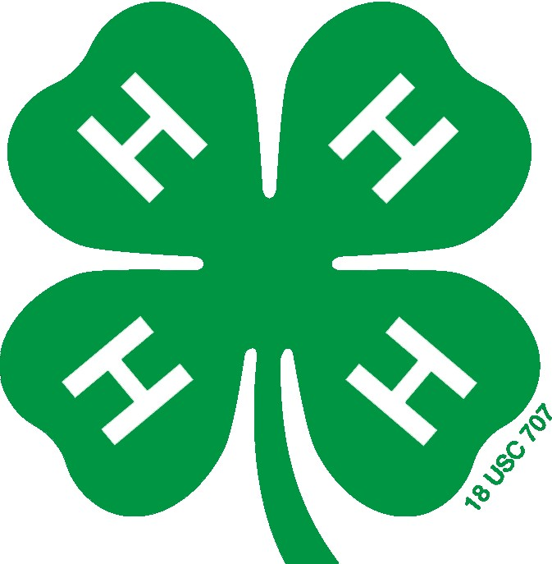

PITT COUNTY 4-H

CLUB RECOGNITION APPLICATION

Directions & Eligibility Requirements

Please READ ALL directions and eligibility requirements carefully before completing the application.
If you have any questions regarding this process, contact the Pitt County Extension 4-H office.

- Clubs must complete this application each year to be eligible for recognition at the annual 4-H Achievement Night

- Pitt County 4-H will recognize clubs that plan and implement well-rounded, educational programs, provide opportunities for members to work toward personal growth, encourage leadership, and demonstrate community responsibility. This is not a competition, but an chance to recognize all clubs that work toward ‘making the best better’ through 4-H experiences.

- DO NOT alter this application.

- Clubs meeting the point requirements will be recognized at the appropriate level. Each club will have its name added to a corresponding plaque that will remain in the county office.

Club of Achievement | Points – 50 to 64 | Certificate & $15
Club of Distinction | Points – 65 to 79 | Certificate & $20
Club of Excellence | Points – 80 + | Certificate & $25

- The information provided must only reflect experiences that occurred during the 4-H program calendar year, January through December 2021.

- Applications without the two required signatures are considered incomplete.

- All applications are due in the Extension office no later than Feb. 25, 2022

- Each club’s information will be reviewed for accuracy.

Thank you for taking time to complete this form and helping 4-H members work toward ‘making the best better.’

DUE DATE: February 25th, 2022

APPLICATION
PITT COUNTY 4-H “CLUB OF THE YEAR”

Club Name _____________________________________
Informational purposes only: Number of years club has been organized yrs

- Club Work & Accomplishments

Charter/Re-Charter Level  - Charter/Re-charter = 2 points  - Emerald Seal = 4 points | pts
Number of meetings held __x 1 =  - Clubs must meet a minimum of 6 times per year- Max of 10pts | pts
Number of new Members __x1 =  - Enrollment forms must be turned in to 4-H office. | pts
Project Record Books submitted to county ______x 1 =  - 1 point per book – Max of 20 pts | pts
Achievement Plans submitted to county _____x 1 =  - Some levels of Achievement Plan cannot be completed in 1 year. | pts
Portfolio Record submitted to county ____x1 =  - 1 point per book – Max of 5 pts. | pts
County Activity Day Presentation ___x 1 =  - 1 point per member | pts
District Activity Day Presentation ____x 1 =  - 1 point per member | pts
State Presentation Competition _____x 1=  - 1 point per member | pts
Community Service Projects  - Planned by club, lasting at least 1 hour, included a minimum of 5 youth members and 1 adult  - 3 points per service project – Maximum of 9 points  - Include a brief summary/statement for each project  List: _______________________ x 3 =  _______________________ x 3 =  _______________________ x 3 = | pts
Section A: Club Work Subtotal:

- Club Involvement – County Level

- County 4-H Council Meeting attendance  Club representation- 2 members represent club at 5 meetings per year.  2 points per meeting with 2 members attending ______ x 2 = | pts
- Club Exhibit booth entered in County Fair ______ x 5 points | pts
- Turned in scrapbook for county competition ____ x 2 points | pts
- Entered a parade, race/walk, or set up marketing display ____ x 5 points | pts
- Submitted an article to a local newspaper _____ x 2 points | pts
Section B County Involvement Subtotal: | pts

- Member Activities / Events Involvement – County, District, State & National
1 point per club – NOT per member
Note: Livestock includes all animals: heifer, goat, sheep, etc.
1. | County Fair – entered an item | pts
2. | State Fair – entered an item | pts
3. | Livestock County Competition | pts
4. | Livestock District Competition | pts
5. | Livestock State Competition | pts
6. | Livestock National Competition | pts
7. | Shooting Sports Regional Competition | pts
8. | Shooting Sports State Competition | pts
9. | Shooting Sports National Competition | pts
10. | Horse Regional Competition | pts
11. | Horse State Competition | pts
12. | Robotics Competition | pts
13. | County Talent Show | pts
14. | County Fashion Revue | pts
15. | NC 4-H Congress | pts
16. | Electric Congress | pts
17. | District Teen Retreat | pts
19. | District 4-H Science Camp | pts
19. | District Council meeting | pts
20. | NC 4-H Citizenship Focus | pts
21. | State ARIE interview | pts
22. | National 4-H event (excluding above list) | pts
23. | TRY-IT Team | pts
24. | Week-long 4-H Summer Camp | pts
25. | 4-H presentation to civic, school or community group | pts
26. | Ambassador Program | pts
27. | Inducted in Honor Club | pts
28. | Taught 4-H summer day camp | pts
29. | Volunteered for 4-H summer day camp | pts
30. | County Meet & Greet Political Event | pts
 | Section C: Activities / Events Involvement Subtotal

A. Club Work Accomplishments Subtotal
B. County Involvement Subtotal
C. Activities / Events Involvement Subtotal
GRAND TOTAL

I certify upon my honor that the information given in this report is true and correct to the best of my knowledge.

DOCUMENT MUST HAVE ALL SIGNATURES BEFORE SUBMISSION

4-H Club Leader Signature Date Club President Signature Date

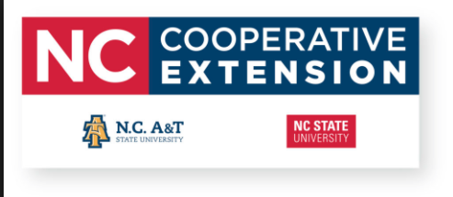

North Carolina State University and North Carolina A&T State University commit themselves to positive action to secure equal opportunity regardless of race, color, creed, national origin, religion, sex, age, veteran status or disability. In addition, the two Universities welcome all persons without regard to sexual orientation.

